Inspection Date | 14/3/2023 | Report Ref. No. | MACINS13 14/3/2023
Site Name |  | Location | Lab R02031
Inspected By | Hend Al Zaabi& Navaz | Witnessed by

Inspection Type | ✓ General ✓ Housekeeping & Sanitation ✓ Fire ✓ Electrical ◻ Ladders ✓ Lab ◻Food ◻ Structure ◻ Motor Vehicles ◻Landscaping ✓ PPE ◻ Stores ◻ Emergency Evacuation

Findings
 | ☑ Safety ☑ Environment ◻ Occupational health
S/N | Description | Significant Risk  Yes/No | Risk Evaluation
S/N | Description | Significant Risk  Yes/No | Low | Med | High
1 | First aider poster details not updated in the lab | Yes
2 | Old first aid items list found placed near to the entrance. | No
3 | Food( Chocolates) found in the lab | No
4 | Electrical panel signage not available | Yes
5 | Observe dirt in the HVAC inlet of ceiling | No
6 | Unapproved power extension cords found used in the lab | Yes
7 | False Ceiling tile not fixed properly | No

Attachment | ◻ Photos ◻ Video Footage ◻ Other

Corrective actions
S/N | Description
 | Short Term Action |  |  | Long Term Action |  | By Whom |  |  |  |  | By When
 | First aider poster details need to be updated |  |  |  |  | Lab in charge |  |  |  | 20-4-2023
 | First aid Equipment sheet need to be removed |  |  |  |  | Lab in charge//FM |  |  |  | 20-4-2023
 | Laboratory safe code of conduct need to be followed. |  |  |  |  | Lab in charge |  |  |  | 20-4-2023
 | Electrical panel singe to be available |  |  |  |  | Lab in charge//FM |  |  |  | 20-4-2023
 | HVAC inlet need to be cleaned |  |  |  |  | Lab in charge//FM |  |  |  | 20-4-2023
 | Power extension need to be replaced with the approved one |  |  |  |  | Lab in charge//FM |  |  |  | 20-4-2023
 | False Ceiling tile need to be fixed properly |  |  |  |  | Lab in charge//FM |  |  |  | 20-4-2023
Prepared by: ESH Section |  |  |  | Received by: |  |  |  | Followed up by:
 |  |  |  | Contractor: | Consultant: |  |  |  | ◻ Corrective Action is taken |  |  |  | ◻ Corrective action not taken
Name |  | Hend Alzaabi | Name |  |  |  | Name |  |  |  |  | Name
Designation |  |  | Designation |  |  |  | Designation |  |  |  |  | Designation
Signature |  |  | Signature |  |  |  | Signature |  |  |  |  | Signature
Date |  |  | Date |  |  |  | Date |  |  |  |  | Date

Attached Photos
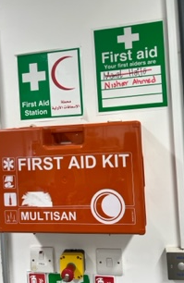  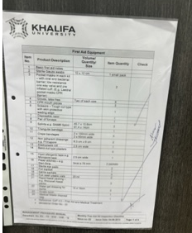 | 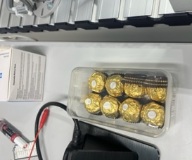
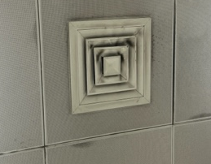 | 